Annemiek Linn,

Faculty of Social and Behavioural Sciences

Course: Persuasive Design in the Digital Era

Group Assignment:

Theoretical Justification

**Csenge Ambrus**

12371939

**Helge Moes**

11348801

**Noah Young**

14489422

**Sophie van Son**

14487519

**Yibei Yu**

14106353

Date: 20/10/2023

Word count: 1992

**Table of Content**

Case Study 3

Defining Target Behavior 3

Medicine Adherence 3

ePI Adoption 4

User-Centred Design Principles 4

Primary Task Support 4

Dialogue Support 5

System Credibility Support 5

Information Processing and Design Choices 5

Simplicity 5

Effective Processing 6

Key information 6

Behavioral Determinants and Persuasive Strategies 6

Perceived Ease of Use and Perceived Usefulness 6

Motivation, Ability, and Triggers 7

Bibliography 8

Appendices 11

Appendix A - Persona 1 11

Appendix B - Persona 2 11

Appendix C - Medication Interaction Warning 12

Appendix D- Medication Image 13

Appendix E- Medication Usage Drawing 14

Appendix F- Medication Restock Reminder 15

Appendix G- Key Information 16

# 

# Case Study

Medicine adherence is crucial for the success of all medicines programs, but the varying health literacy of our general populations mean that steps or details are often missed. While The Medicines Evaluation Board (MEB) offers electronic product information (ePI) leaflets for medications in the form of PDFs, these can be lengthy and difficult to read for those with mixed abilities and/or health literacy.

As development of a Netherlands-wide personal health environment (PGO) is in process, The MEB seeks to embed a module within the PGO that offers a more user-friendly and accessible version of their ePI, which has the additional benefits of tracking medical interactions and allergies, as well as nudging users to take their medications on time.

This theoretical justification showcases the literature that is implemented in the prototype of the new MEB module: *my ePI*.

# Defining Target Behavior

The *my ePI* module was designed to address medicine adherence and the adoption of the ePI in the PGO, using Fogg's Behavior Model (Fogg, 2009), the Behavior Change Wizard by Fogg and Hreha (2010) and the technology acceptance model (Davis, 1989) to guide the design process.

Hammer et al. (2016) highlight the challenges of implementing an ePI, nudging users, and what eHealth services can be used to persuade the general public. Patient use of product information leaflets (PILs) has shown to increase patients’ satisfaction with healthcare professionals and improve Doctor-Patient Communication (Sustersic et al., 2019).

Using interviews and theory two target behaviours were identified, namely: adoption of the ePI into the PGO (microsuasion) and medicine adherence (macrosuasion) (Lustria & van Weert, 2023).

## Medicine Adherence

Fogg and Hreha (2010) devised a matrix of behavioural changes to help guide persuasive design. Of these behavioural change types, improving medicine adherence is a “BluePath” behaviour change, meaning users are asked to perform a familiar behaviour (reading the PIL) for an indefinite amount of time (permanent change).

The key determinants to change medicine adherence, according to Fogg’s behaviour model (Fogg, 2009), are motivation, ability, and triggers. The *my ePI* module addresses motivation by highlighting the benefits of medicine adherence and alerting users of the dangers and potential side effects of non-adherence. Ability is addressed by keeping the layout and design simple, as well as making accessibility a pillar in the design process and offering tutorials to aid in module use. Triggers come in the form of reminders which can be personalised by the user to ensure effectiveness.

## ePI Adoption

ePI adoption is a “GreenPath” behaviour (Fogg and Hreha, 2010), as we ask users to perform a new task (adding the ePI to their PGO) and then continuing to use it (permanent behaviour). The behavioural change theory that addresses the adoption of the ePI into the PGO is the technology acceptance model (Davis, 1989). From this model, two clear determinants, perceived ease of use and perceived usefulness, were deemed the most pivotal in exacting behavioural change. The *my ePI* prototype was designed user-first, meaning perceived ease of use and perceived usefulness were at the forefront in every element of the design, to ensure that any and all users could easily and intuitively use the module in a manner that led to positive change in their lives.

# User-Centred Design Principles

Throughout the research and design process, the primary sources of guidance were the Persuasive System Design Model (PSD) and the Behavioral Change Support System (BCSS). In the design of the *my ePI* prototype, primary task support, dialogue support and system credibility support were emphasised (Merz & Ackermann, 2021).

## Primary Task Support

Self-monitoring is exhibited in the ability of users to: log their symptoms and what they eat/drink, log whether they have taken their medication, and most importantly, review their log history. Self-monitoring was confirmed to be a desirable feature during interviews performed to create the personas (see Appendices A and B), as interviewees reflected that they occasionally struggled to remember to take their medications and/or wanted better oversight of their medication usage to aid in doctor-patient interactions.

Personalisation was also a key element in the design of *my ePI*. From the moment a user signs up, an intake survey aids in the customisation of the module content and lay out, to ensure it accurately targets users’ individual needs. A study by Al Jeraisy et al. (2023) found that whether users read and understand and read the PILs is influenced by sex, age, and education. Age, and specifically generational differences in eHealth literacy (Magsamen-Conrad et al., 2020), were a key problem point to address in the design. One key personalisation feature was the ability to change the font size, since as people age, eyesight deteriorates. Personalisation in *my ePI* further includes being able to change the names of the medications, e.g., to something easier to remember or understand (to health those with low health literacy).

## Dialogue Support

One key principle of dialogue support was implemented into *my ePI*: reminders. Vervloet et al. (2012) found that electronic reminders resulted in improvement of short-term adherence to chronic medication by the patient. Based on the BCSS dialogue support principles and Vervloet et al., as well as the need of our interviewees to be reminded, notifications were added into the *my ePI* module. These notifications can be set up and customised at any time by the user, to aid the user in positive long-term improvements in medicine adherence.

## System Credibility Support

Diviani et al. (2015) identified a negative relationship between low health literacy and the ability to assess and trust online health information. In order to assure users of the credibility of the module, logos of trustworthy stakeholders in the module (the MEB) are used at the home screen. The login screen also offers the ability to log in using DigiD, which further exemplifies the confidential nature of the app. Additionally, when signing up, the user is shown a message which states outright that data collected within this app is confidential and party to only the user themself, unless otherwise explicitly stated. The only possibility during which data may be shared is when the user clicks a button to consent to sending their symptom log to LAREB, a pharmacovigilance centre.

The source of all the data is also based strictly on information approved by the MEB, which is clearly stated in the Chat Bot feature as well, to assure the users.

# Information Processing and Design Choices

## Simplicity

When patients attempt to learn about the causal properties of a medication (how it works, how well, how quickly and if there are any side effects), they are often overwhelmed with complex and cognitively overloading information. This form of information is shown to result in lower levels of cognitive processing. Rottman et al. (2016) state that a key challenge of teaching patients about their medication is that they usually desire to reach a conclusion about a medication from relatively little data. One of the solutions the research suggests in order to combat medication nonadherence is to explain to patients what side effects there could be in a simplistic way; this will combat any possible worries, misconceptions or prior beliefs that may impact medication adherence. This was implemented in the design through a feature which displayed possible side effects of specific medications and possible side effects that may arise when using multiple medications using simplistic wording (See Appendix C).

## Effective Processing

According to Lang (2006), in order to process the information effectively, one must encode, store and retrieve the information. We used some of the LC4MP major assumptions as key influences when designing the portal, the first being the nature of media. We all process information differently depending on the presentation format (whether that be through words, text, still pictures, moving pictures, sounds, etc.). Therefore, we used many formats to present our information: text, real images of medication packaging, icons, tutorials in the form of short videos, as well as offering settings to customise font size and image size (See Appendices D & E). The use of icons and minimal text helps to aid those with lower health literacy and gain their trust (Schubbe et al., 2020; Diviani et al., 2015).

Secondly, the nature of time was taken into account. Human behaviour is constantly evolving and changing. As a result, human cognition is a dynamic process which can be influenced based on motivation at a current period, distractions or lack of sleep, for example. We implemented a reminder notification feature to our design, which can nudge users to restock their current medication supply (See Appendix F).

## Key information

In addition to these key features, we implemented a key information section in the ePI as it gave users simple information at a glance, allowing them to process it quickly. Van Dijk et al., (2014) conducted a study on the implementation feasibility and value of a possible “key information section” in PILs. This helped inspire many elements of the proposed ‘key information’ section, since it increases the chance that the user gains an overall better understanding of the medication they are taking or planning to take, compared to the laborious and possibly cognitively overloading process of reading the full ePI (See Appendix G). However, if the user wants a specific piece of information that is not available in the 'key information' section, they also have the option to view the full ePI.

# Behavioral Determinants and Persuasive Strategies

## Perceived Ease of Use and Perceived Usefulness

Vaghefi and Tulu (2019) found that people prefer clean and simple interface design, which is relevant to the design principle of reduction (Merz & Ackermann, 2021). Therefore, each page is distinctly functional in the prototype, without large blocks of text and intricate tasks. The daily use features are placed on the homepage to minimise the need for users to navigate back and forth. Additionally, practical training sessions cansessions, that include initial education and ongoing follow-ups, can help users comprehend the purpose and role of the app in their own condition, which contributes to their perceived ease of use (Fitzgerald & McClelland, 2016). As such, tutorials and instructions are provided in the prototype for reference.

Wang and Qi (2021) proposed the core functions, information quality and personalization that influence people’s perceived usefulness of the health application. Most users choose health apps for specific purposes, reflecting the importance of functions and meeting their needs for satisfaction and ongoing usage (Yan et al., 2021). Mendiola et al. (2015) found that users highly value tailored information and actionable insights specific to their condition and its management. Our prototype covers the functions that potential users desire, including identifying medical interactions, warning of side effects, notifying and tracking medication intake, and contacting medical practitioners. The intake survey and daily log makes sure the information is personalised.

## Motivation, Ability, and Triggers

In terms of medicine adherence, according to Linn et al. (2012), people’s low regard for the necessity of their medication and high concern with its negative effects decreases people’s motivation of medicine adherence. They also proposed that practical barriers exist, including memory and daily routine, that hamper taking medications on time (Linn et al., 2012).

To address the users’ motivation and ability, the persuasive strategies of tailoring, information retrieval improvement, and user engagement were employed in the module. Providing patients with information that they view as tailored and of high quality is crucial for addressing their beliefs and consequently enhancing adherence (Linn et al., 2014). Recall-promoting techniques including emphasising and repeating information, avoiding jargon, and involving users in the problem-solving and decision-making process can not only deal with practical barriers but also help motivate people (Linn et al., 2012). In our design, users are able to rename the medicines to avoid jargon and personalise their medication cabinet. Their medicines are presented both on the homepage and the medication cabinet, where information is repeated and emphasised. Users can also make their own decisions on whether to set a reminder and whether to contact their GP or chatbot when medical interaction occurs.

# 

# 

*Table 1: Behaviours, determinants and strategies implemented in the prototype*

# Bibliography

Al Jeraisy, M., Alshammari, H., Albassam, M., Al Aamer, K., & Abolfotouh, M. A. (2023). Utility of patient information leaflet and perceived impact of its use on medication adherence. *BMC Public Health, 23*(1), 488.<https://doi.org/10.1186/s12889-023-15346-y>

Davis, F. D. (1989). Perceived Usefulness, Perceived Ease of Use, and User Acceptance of Information Technology. *MIS Quarterly*, *13*(3), 319-340.<https://doi.org/10.2307/249008>

Diviani, N., Putte, B. van den, Giani, S., & Weert, J. C. van. (2015). Low Health Literacy and Evaluation of Online Health Information: A Systematic Review of the Literature. *Journal of Medical Internet Research*, *17*(5), e4018.<https://doi.org/10.2196/jmir.4018>

Dijk , L., Vervloet, M., Monteiro, S. P., Burgt, S., & Raynor, D. T. (2014). Feasibility and value of a possible “key information section” in patient information leaflets and summaries of product characteristics of medicinal products for human use: The PILS-BOX study. *EU Health Programme*.

Fitzgerald, M., & McClelland, T. (2016). What makes a mobile app successful in supporting health behaviour change? *Health Education Journal*, *76*(3), 373–381. https://doi.org/10.1177/0017896916681179

Fogg, B. J. (2009). A behaviour model for persuasive design. *Proceedings of the 4th International Conference on Persuasive Technology*, 40, doi:  [1145/1541948.1541999L](https://doi.org/10.1145/1541948.1541999)

Fogg, B. J., & Hreha, J. (2010). Behavior wizard: A method for matching target behaviors with solutions. In *Persuasive Technology: 5th International Conference, PERSUASIVE 2010, Copenhagen, Denmark, June 7-10, 2010. Proceedings 5* (pp. 117-131). Springer Berlin Heidelberg.

Fotheringham, M. J., Owies, D., Leslie, E., & Owen, N. (2000). Interactive health communication in preventive medicine: Internet-based strategies in teaching and research. *American Journal of Preventive Medicine*, *19*(2), 113-120. [https://doi.org/10.1016/S0749-3797(00)00188-](https://doi.org/10.1016/S0749-3797(00)00188-4)

Hammar, T., Nilsson, A.-L., & Hovstadius, B. (2016). Patients’ views on electronic patient information leaflets. *Pharmacy Practice (Granada)*, 14(2), 0-0.<https://doi.org/10.18549/PharmPract.2016.02.702>

Lang, A. (2006). Using the Limited Capacity Model of Motivated Mediated Message Processing to Design Effective Cancer Communication Messages. *Journal of Communication*, *56*(s1), S57-S80.<https://doi.org/10.1111/j.1460-2466.2006.00283.x>

Linn, A. J., Weert, J. C. van, Schoutena, B. C., Smit, E. G., Bodegraven, A. A. van, & Dijk, L. van. (2012). Words that make pills easier to swallow: A communication typology to address practical and perceptual barriers to medication intake behavior. *Patient Preference and Adherence*, *6*, 871-885.<https://doi.org/10.2147/PPA.S36195>

Linn, A. J., Van Weert, J. C., Van Dijk, L., Horne, R., & Smit, E. G. (2014). The value of nurses’ tailored communication when discussing medicines: Exploring the relationship between satisfaction, beliefs and adherence. *Journal of Health Psychology*, *21*(5), 798–807. https://doi.org/10.1177/1359105314539529

Lustria, M. L. A., & Van Weert, J. C. M. (2023). Persuasive Technologies for Health. *The International Encyclopedia of Health Communication.*

Magsamen-Conrad, K., Wang, F., Tetteh, D., & Lee, Y. I. (2020). Using technology adoption theory and a lifespan approach to develop a theoretical framework for eHealth literacy: extending UTAUT. *Health communication*, *35*(12), 1435-1446.

Mendiola, M. F., Kalnicki, M., & Lindenauer, S. (2015). Valuable features in mobile health apps for patients and consumers: content analysis of apps and user ratings. *Jmir Mhealth and Uhealth*, *3*(2), e40. https://doi.org/10.2196/mhealth.4283

Merz, M., & Ackermann, L. (2021). Design principles of persuasive systems–review and discussion of the persuasive systems design model. *AMCIS 2021 Proceedings. 3.* <https://aisel.aisnet.org/amcis2021/sig_hci/sig_hci/3>

Rottman, B. M., Marcum, Z. A., Thorpe, C. T., & Gellad, W. F. (2017). Medication adherence as a learning process: Insights from cognitive psychology. *Health Psychology Review*, *11*(1), 17-32.<https://doi.org/10.1080/17437199.2016.1240624>

Schubbe, D., Scalia, P., Yen, R. W., Saunders, C. H., Cohen, S., Elwyn, G., ... & Durand, M. A. (2020). Using pictures to convey health information: A systematic review and meta-analysis of the effects on patient and consumer health behaviors and outcomes. *Patient education and counseling*, *103*(10), 1935-1960.

Sustersic, M., Tissot, M., Tyrant, J., Gauchet, A., Foote, A., Vermorel, C., & Bosson, J. L. (2019). Impact of patient information leaflets on doctor-patient communication in the context of acute conditions: A prospective, controlled, before-after study in two French emergency departments. *BMJ Open*, *9*(2), e024184.<https://doi.org/10.1136/bmjopen-2018-024184>

Vaghefi, I., & Tulu, B. (2019). The continued use of mobile health apps: Insights from a longitudinal study. *Jmir Mhealth and Uhealth*, *7*(8), e12983. https://doi.org/10.2196/12983

Vervloet, M., Linn, A. J., van Weert, J. C. M., de Bakker, D. H., Bouvy, M. L., & van Dijk, L. (2012). The effectiveness of interventions using electronic reminders to improve adherence to chronic medication: A systematic review of the literature. *Journal of the American Medical Informatics Association*, *19*(5), 696-704.<https://doi.org/10.1136/amiajnl-2011-000748>

Wang, C., & Qi, H. (2021). Influencing Factors of Acceptance and Use Behavior of Mobile Health Application Users: Systematic Review. *Healthcare*, *9*(3), Article 3.<https://doi.org/10.3390/healthcare9030357>

Yan, M., Filieri, R., Raguseo, E., & Gorton, M. (2021). Mobile apps for healthy living: Factors influencing continuance intention for health apps. *Technological Forecasting and Social Change*, *166*, 120644. https://doi.org/10.1016/j.techfore.2021.120644

# Appendices

## Appendix A - Persona 1

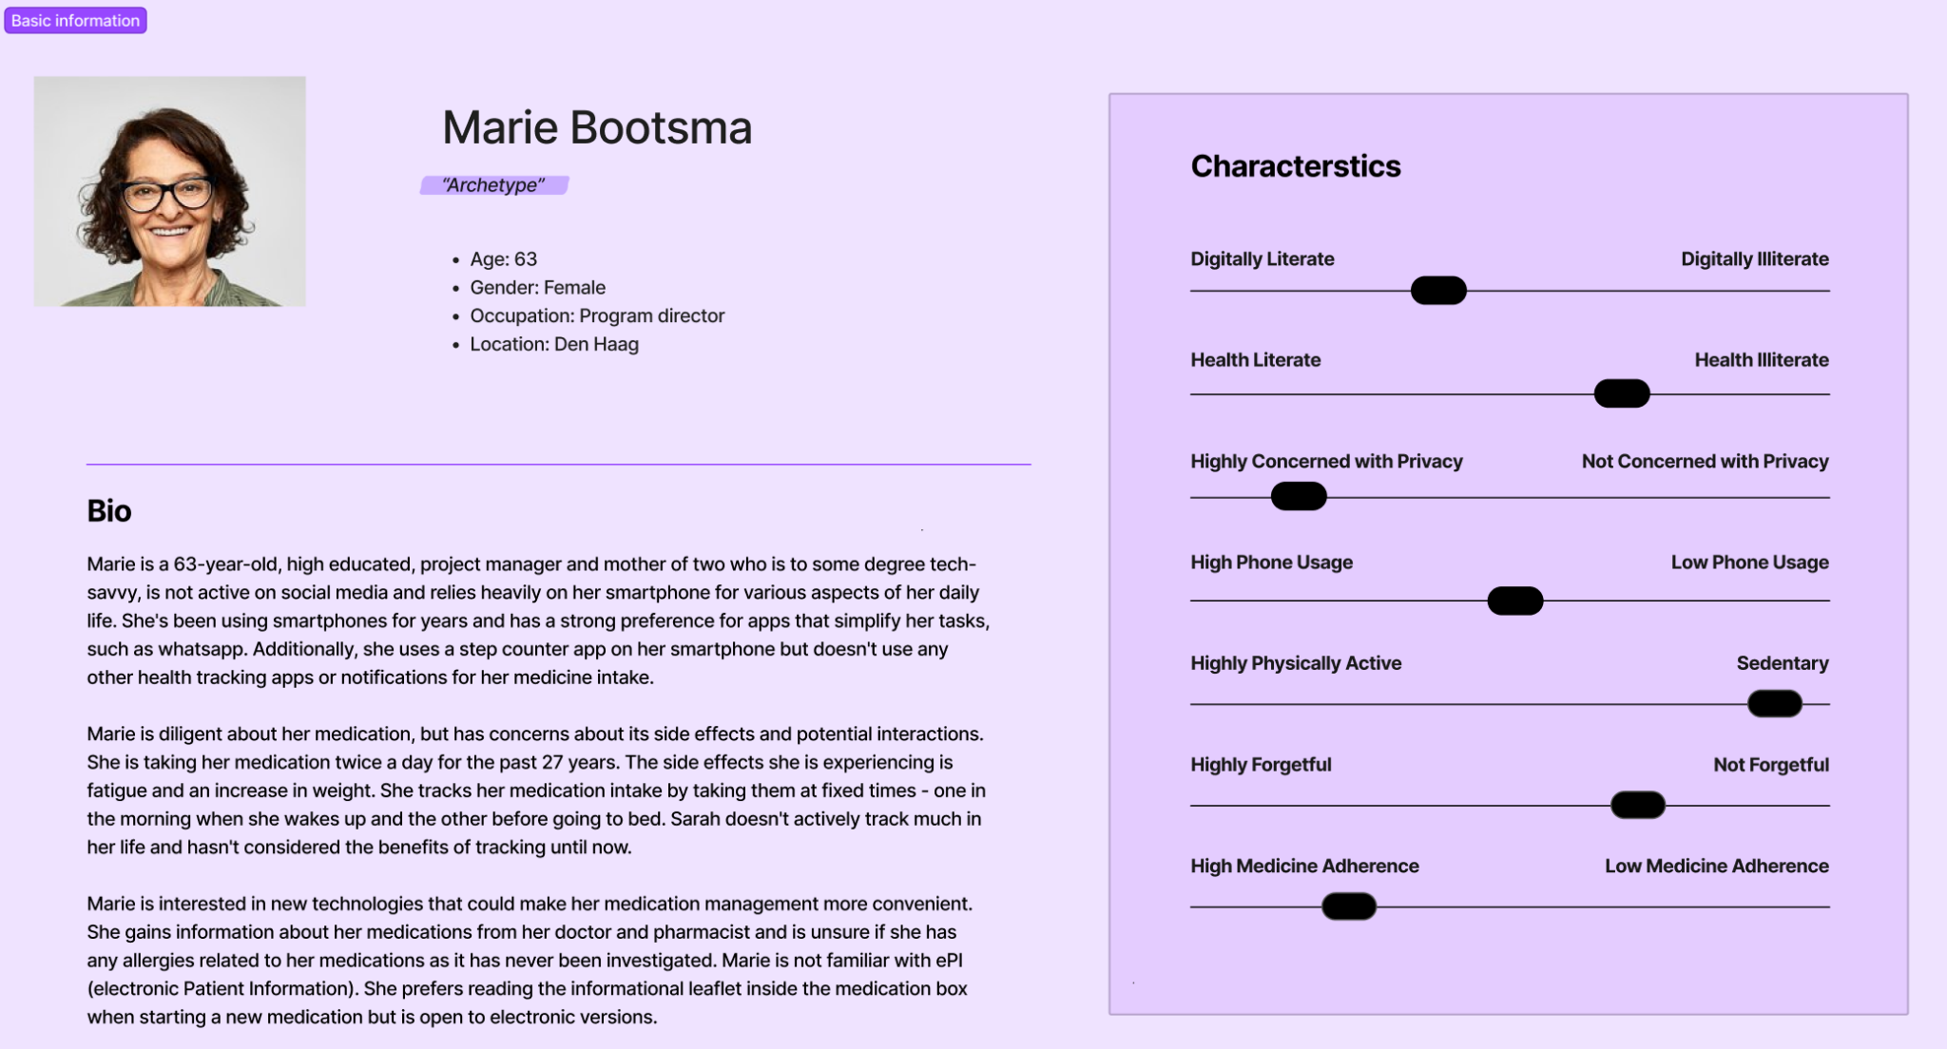

*Figure 1: Persona 1, Marie Bootsma*

## Appendix B - Persona 2

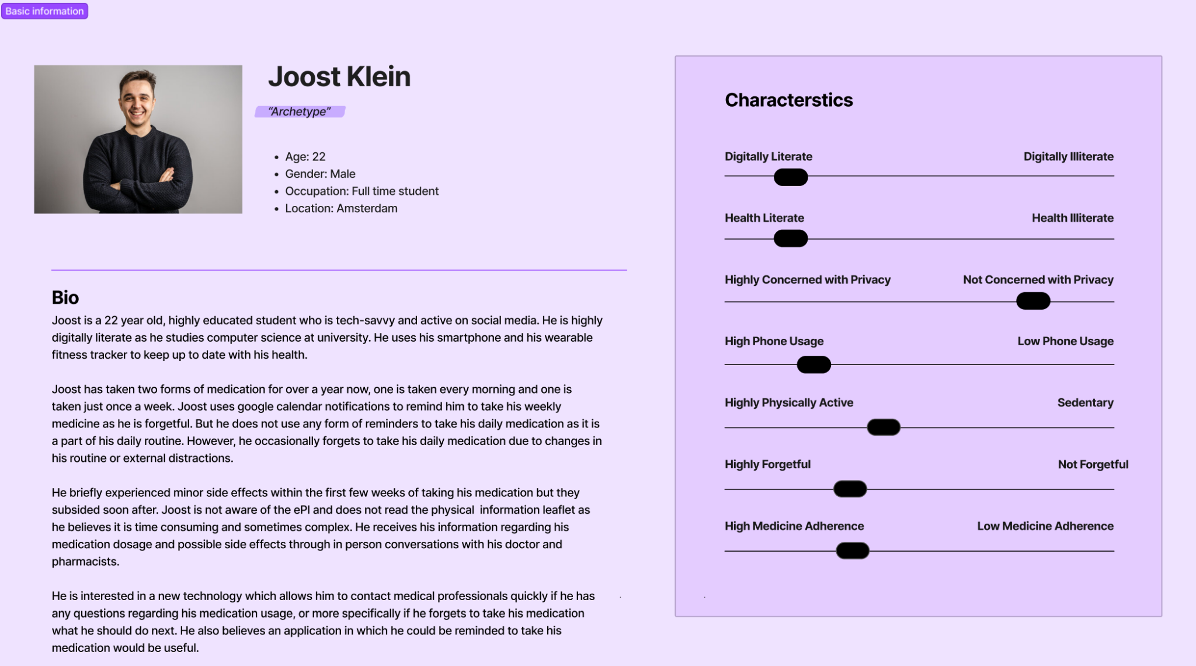

*Figure 2: Persona 2, Joost Klein*

## Appendix C - Medication Interaction Warning



*Figure 3: Medication interaction warning pop up*

## Appendix D- Medication Image

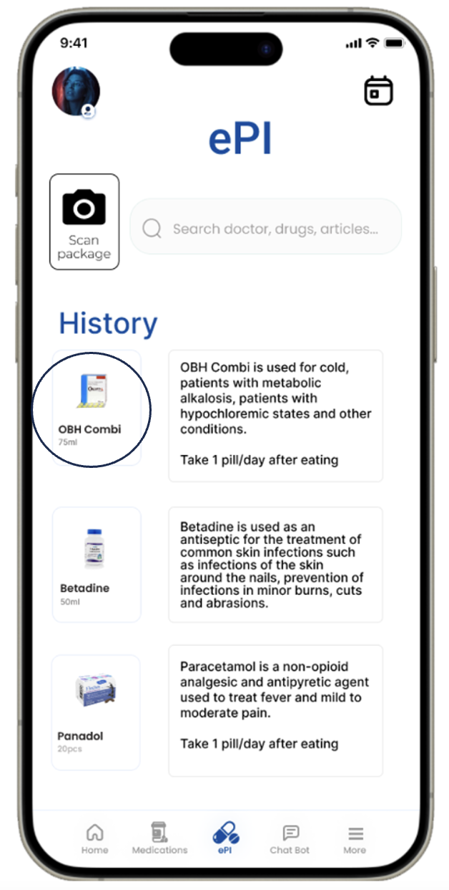

*Figure 4: Use of medication image to display information*

## Appendix E- Medication Usage Drawing

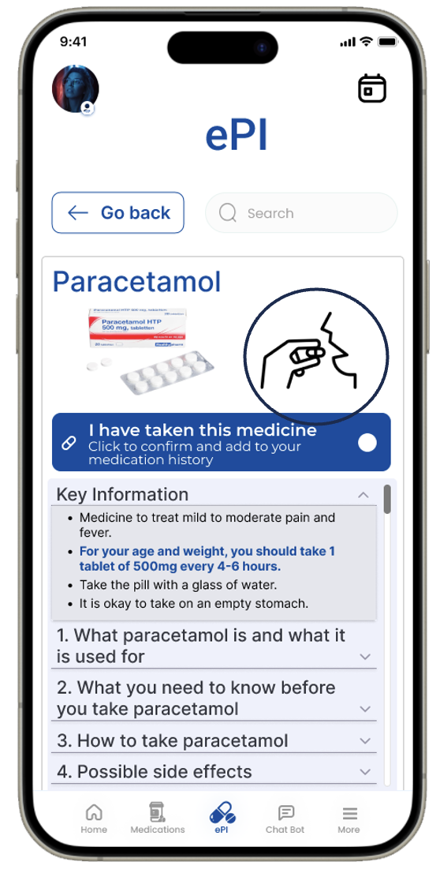

*Figure 5: Use of medication drawing to display usage information*

## Appendix F- Medication Restock Reminder

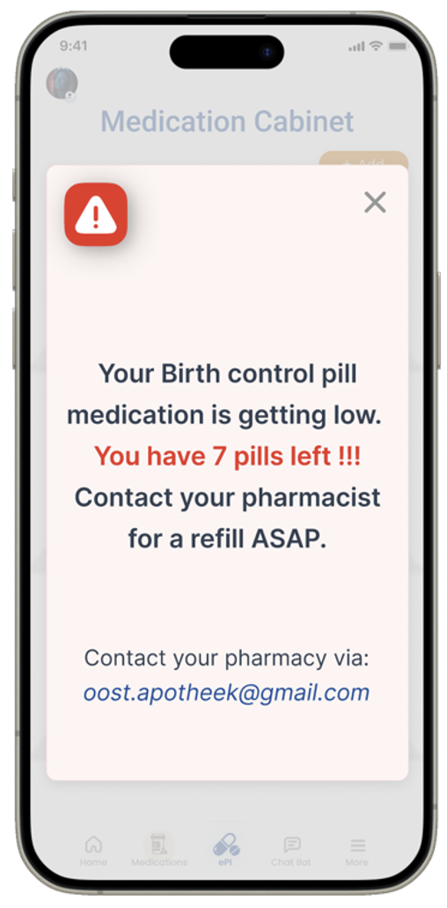

*Figure 6: Reminder message to restock medication due to low supplies*

## Appendix G- Key Information

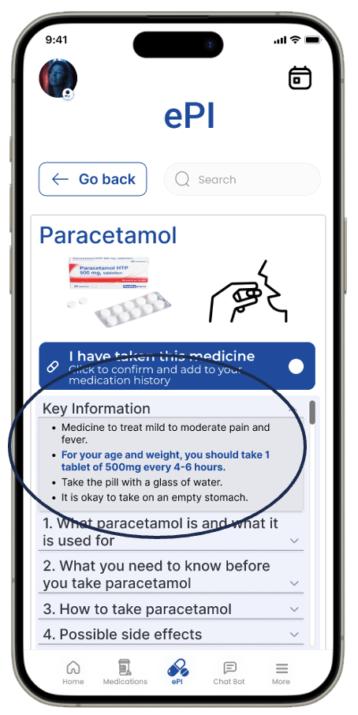

*Figure 7: Medication key information*